CS 340 Project Two: Grazioso Salvare Dashboard
Student: Savannah Pierce
Course: CS 340 Client/Server Development
Project: Project Two – MongoDB Dashboard for Grazioso Salvare
Project Overview
This project involved the development of a client-facing dashboard for Grazioso Salvare, an organization that trains rescue dogs for search-and-rescue operations. The dashboard connects to a MongoDB database containing Austin Animal Center animal records and allows users to filter and visualize data related to dogs that meet specific rescue-training criteria.
The dashboard was developed using Python, MongoDB, Dash, Dash Leaflet, and Plotly. Users can interact with the dashboard through filter controls that update the data table, pie chart, and geolocation map dynamically.

Required Functionality
The completed dashboard provides the following functionality:
- Displays an interactive data table containing animal shelter records.
- Allow users to filter records using rescue categories:
  - Water Rescue
  - Mountain or Wilderness Rescue
  - Disaster or Individual Tracking
  - Reset
- Updates the data table dynamically based on the selected rescue type.
- Displays a pie chart showing breed distribution for the filtered records.
- Displays a geolocation map showing animal locations.
- Includes the Grazioso Salvare logo.
- Includes a unique identifier displaying the developer's name.

Dashboard Screenshots
Dashboard Startup State
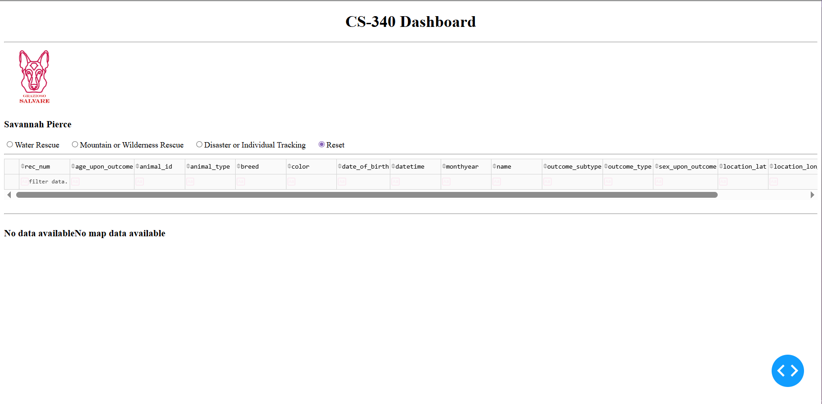Water Rescue Filter Applied
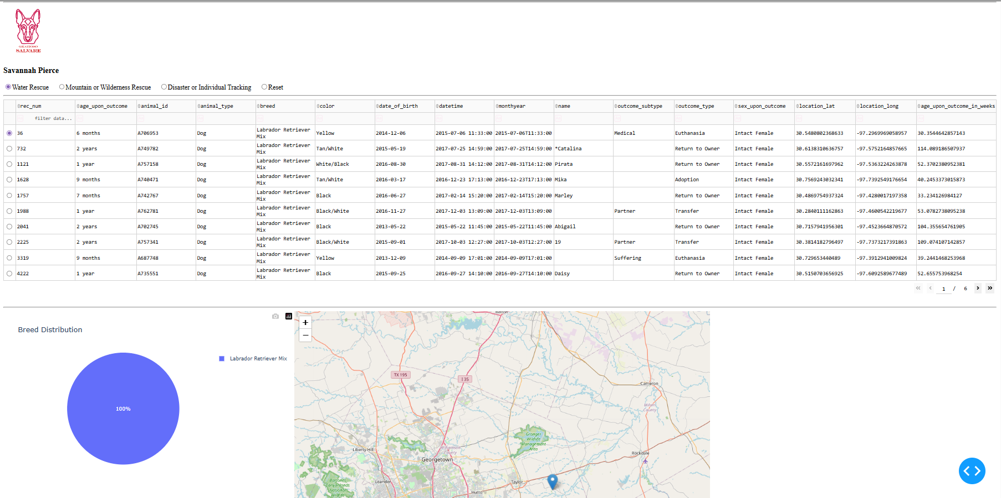

Mountain or Wilderness Rescue Filter Applied
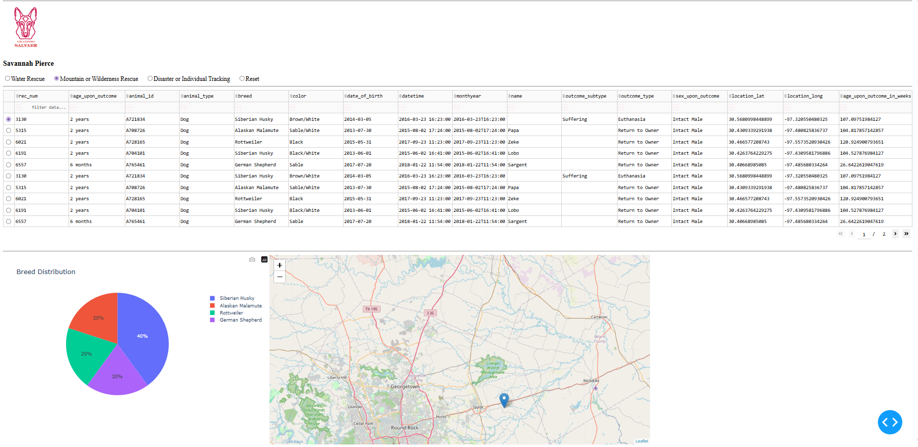Disaster or Individual Tracking Filter Applied
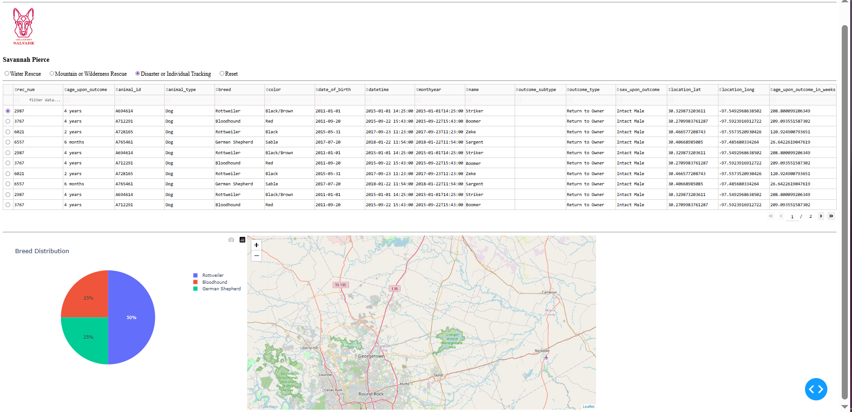

Reset Filter Applied
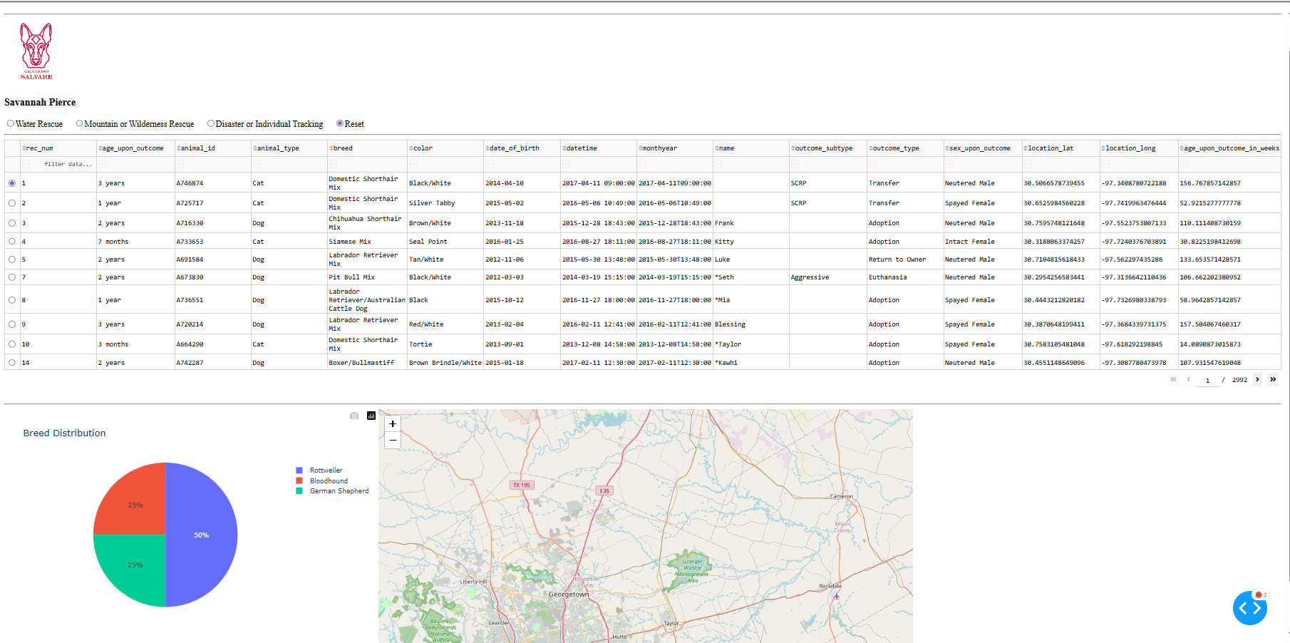
Tools and Technologies Used
MongoDB
MongoDB was used as the model component of the application. MongoDB stores information as flexible JSON-like documents, making it well suited for handling animal shelter records. Through the PyMongo library, MongoDB integrates directly with Python and allows efficient retrieval and filtering of data.
Python
Python was used as the primary programming language for developing the CRUD module, dashboard callbacks, database queries, and data processing logic.
Dash Framework
Dash was used to create the web-based dashboard interface. Dash provides interactive web components that allow users to filter information and automatically update dashboard elements without requiring JavaScript development.
Plotly Express
Plotly Express was used to create the breed distribution pie chart. The chart updates automatically based on the selected rescue filter.

Dash Leaflet
Dash Leaflet was used to create the interactive geolocation map displaying animal locations from the database.
Pandas
Pandas was used to manage and manipulate data returned from MongoDB before displaying it in dashboard components.

Resources Used
- SNHU CS 340 Dashboard Specifications Document
- Austin Animal Center Outcomes Dataset
- MongoDB Documentation
- Dash Documentation
- Plotly Documentation
- Dash Leaflet Documentation
- PyMongo Documentation

Steps Taken to Complete the Project
- Created a CRUD Python module to connect to MongoDB and perform create, read, update, and delete operations.
- Loaded Austin Animal Center records into MongoDB.
- Developed an interactive Dash dashboard.
- Displayed all records in an unfiltered data table.
- Created MongoDB queries for each rescue category.
- Added radio button controls for rescue-type selection.
- Connected the controls to dashboard callbacks.
- Created a dynamic breed distribution pie chart.
- Created a dynamic geolocation map using Dash Leaflet.
- Added the Grazioso Salvare logo and unique identifier.
- Tested all dashboard functionality and verified that filters updated the table and charts correctly.
- Captured screenshots demonstrating successful execution.

Challenges Encountered and Solutions
One challenge encountered during development involved connecting the dashboard filters to the MongoDB queries. Initially, the dashboard returned errors when switching between rescue categories because the callback functions were not handling empty datasets properly. This issue was resolved by adding validation checks before processing the returned records.
Another challenge involved configuring the interactive map. Indexing errors occurred when no row was selected in the data table. This was resolved by assigning a default row selection and validating the selected index before displaying map data.
Finally, dashboard styling and layout required adjustments to ensure that the data table, chart, and map displayed correctly and responded to user interactions as intended.

Reproduction Instructions
To reproduce this project:
- Install MongoDB.
- Import the Austin Animal Center dataset into the MongoDB aac database.
- Place the animal_shelter.py CRUD module in the project directory.
- Open ProjectTwoDashboard.ipynb.
- Verify that the MongoDB username and password match the local environment.
- Run all notebook cells.
- Launch the dashboard through JupyterDash.
- Use the rescue filter controls to interact with the data table, pie chart, and map.

